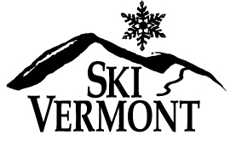

Ski Vermont would like to give you the opportunity to carve out even more days on your favorite Vermont slopes!

As both a previous and current VIP purchaser, we know you are already aware of the great value the VIP passes give businesses and winter lovers alike.

Do you know of any other out of state businesses who would like to get in on this great deal? After all, even for purchasers who are not as lucky as you to get the early bird rate, tickets still come out to under $30 each! Ski Vermont would be happy to reach out to them and provide Ski VIP Pass program information.

If you are able to refer another business to us who decides to participate in our VIP Pass Program with the purchase of at least one VIP booklet, we will give your business 8 extra VIP Ski Passes to the resorts* of your choice. *Up to 4 passes per resort. All 8 passes cannot be for the same resort. If purchase occurs, Ski VT will be in contact with you to determine you ticket request.

Please provide the information to us rather than forwarding the information we provide you in the event the referred company/organization is not eligible for the program offer.

Referred Business Name:______________________________________________

Referred Business Address/Location:

Contact Name: ______________________________________________________

Contact Address and/or Email Address to provide VIP information:___________________________________

Your Company Name: _________________________________________________

Your Preferred Contact Information:______________________________________________

(Will use same email/phone number as on your original application unless otherwise specified)

This would be to contact you in the event of purchase to determine the additional ticket allotment.

Please email this completed form to alicia@skivermont.com